**EXPERIMENT - 8**

**AIM OF THE EXPERIMENT:**

To design and verify V to I and I to V converter using multisim

**APPARATUS REQUIRED:**

PC loaded with multisim software

**THEORY:**

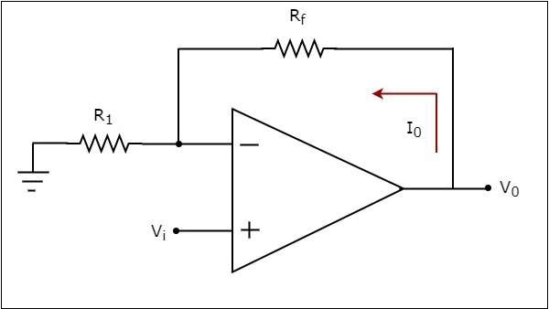An op-amp based voltage to current converter is an electronic circuit that produces an output current when a voltage is applied to its non-inverting terminal.

I0/Vi=1/R1

We know that the ratio of the output and the input of a circuit is called as gain. So, the gain of an voltage to current converter is the Transconductance and it is equal to the reciprocal of resistance R1.

An op-amp based current to voltage converter  is an electronic circuit that produces an output voltage when current is applied to its inverting terminal.

V0/Ii=−Rf

We know that the ratio of output and input of a circuit is called as gain. So, the gain of a current to voltage converter is its trans resistance and it is equal to the (negative) feedback resistance Rf .

**VERIFICATION:**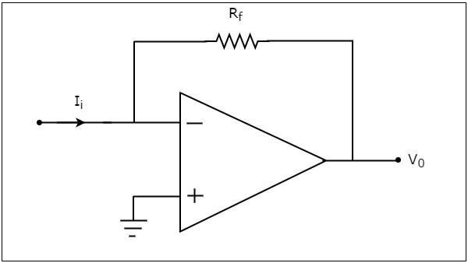

V to I converter

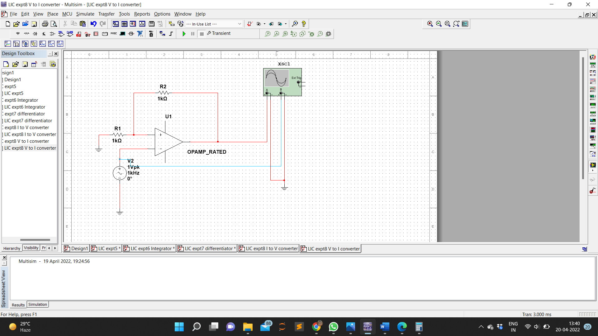Circuit Diagram

Input Voltage

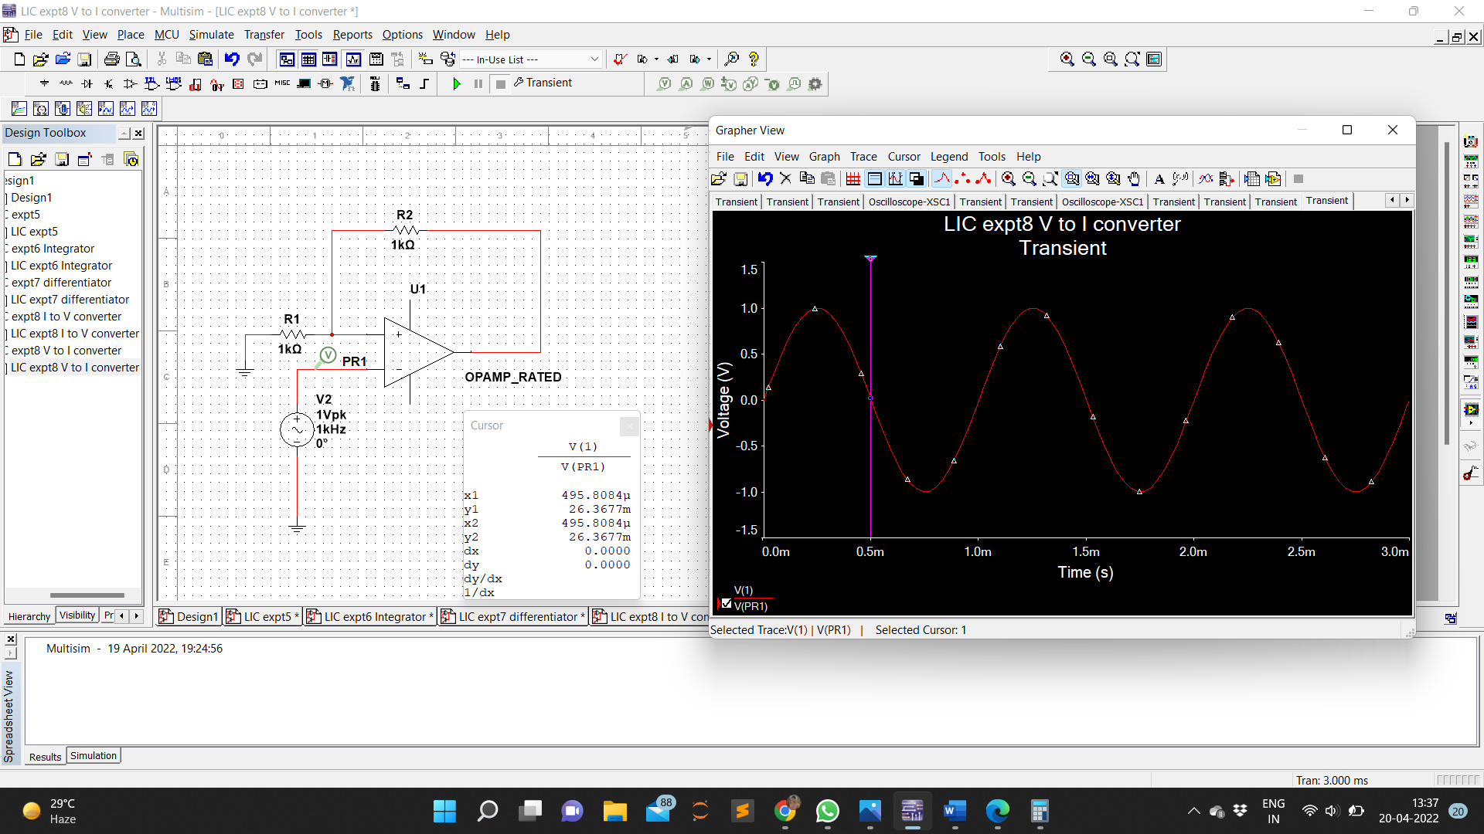

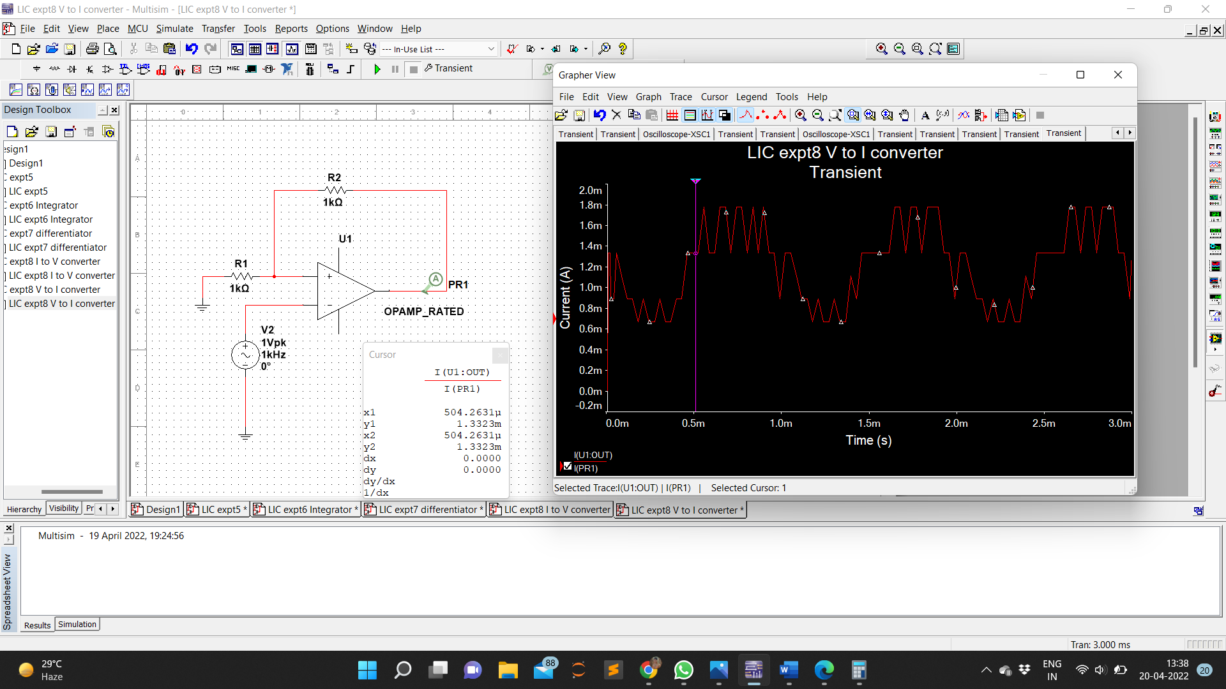Output Current

Waveform

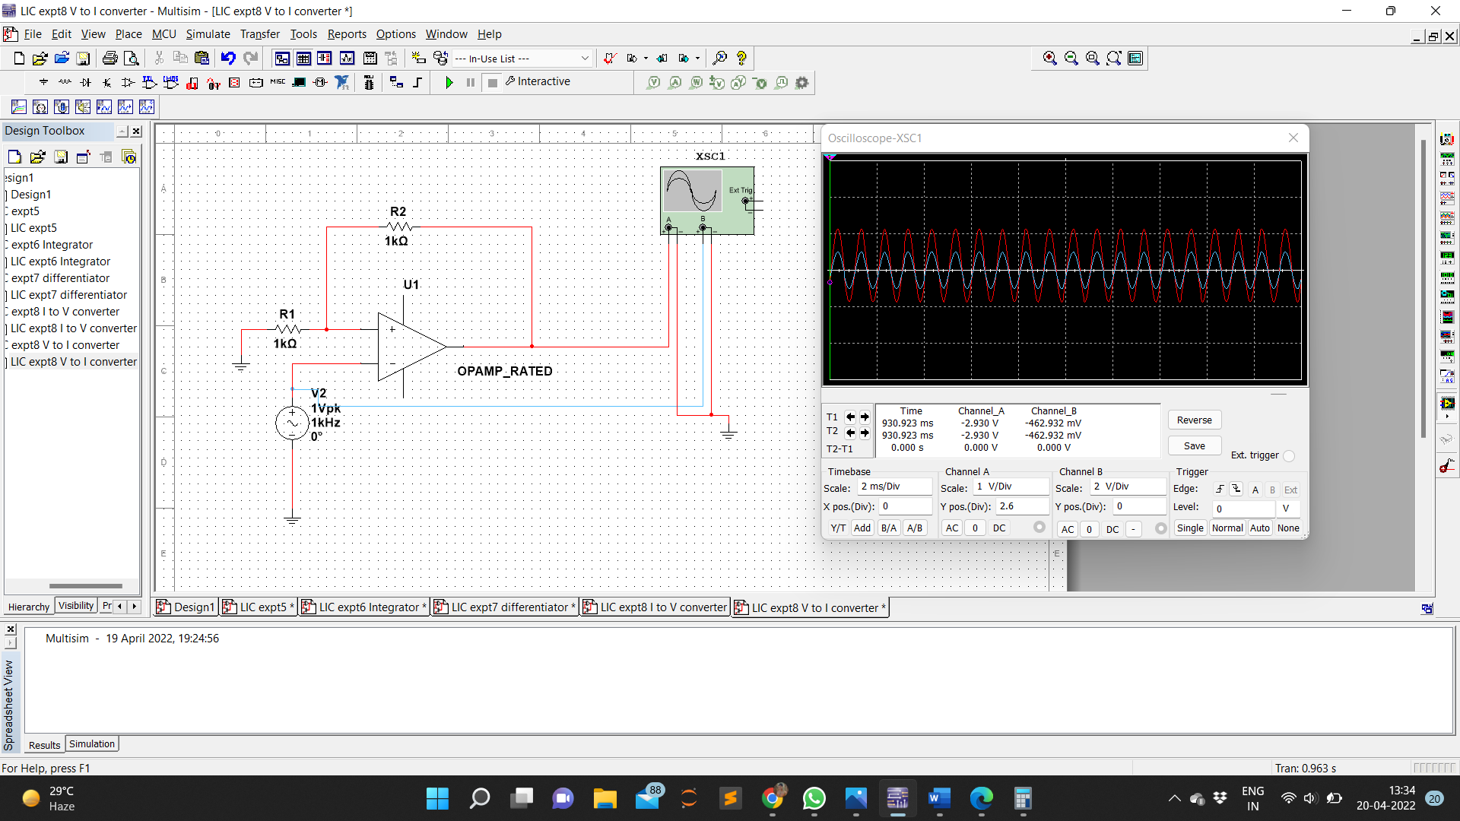

I to V converter

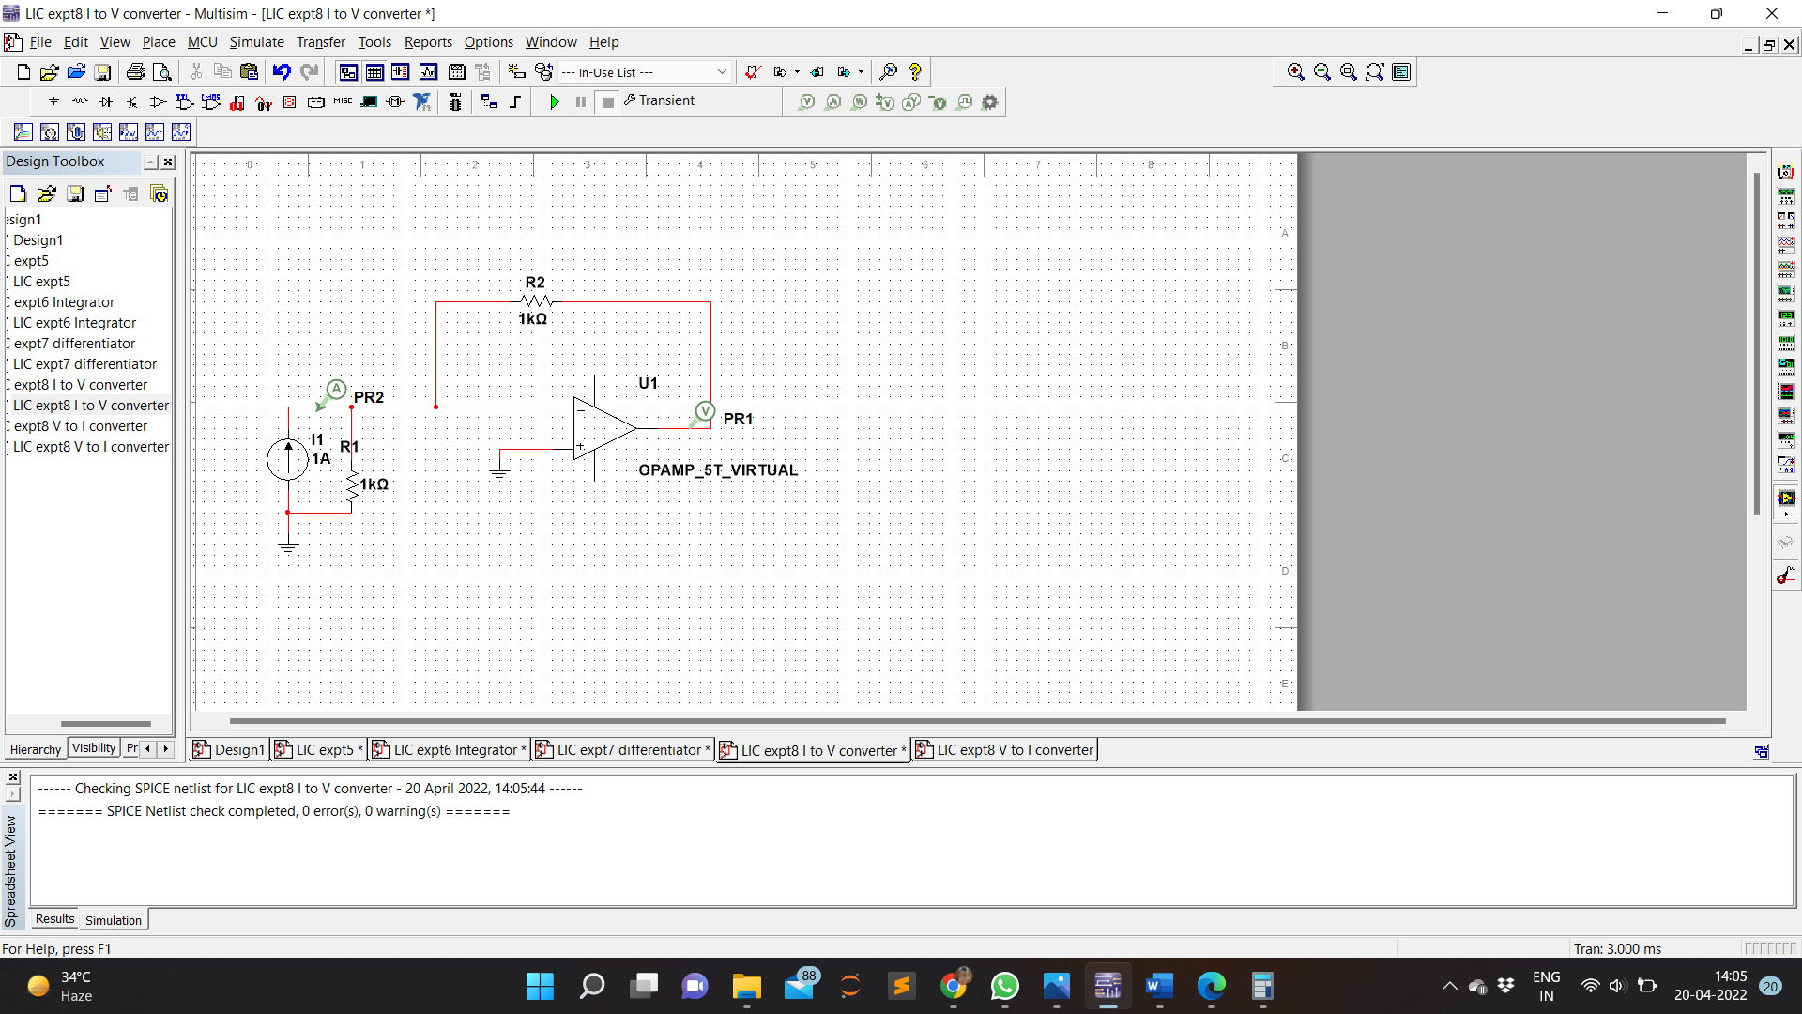Circuit Diagram

Input Current

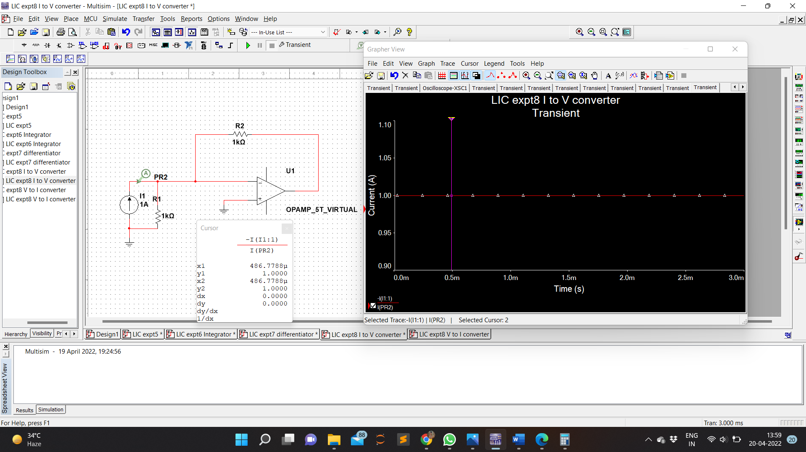

Output Voltage

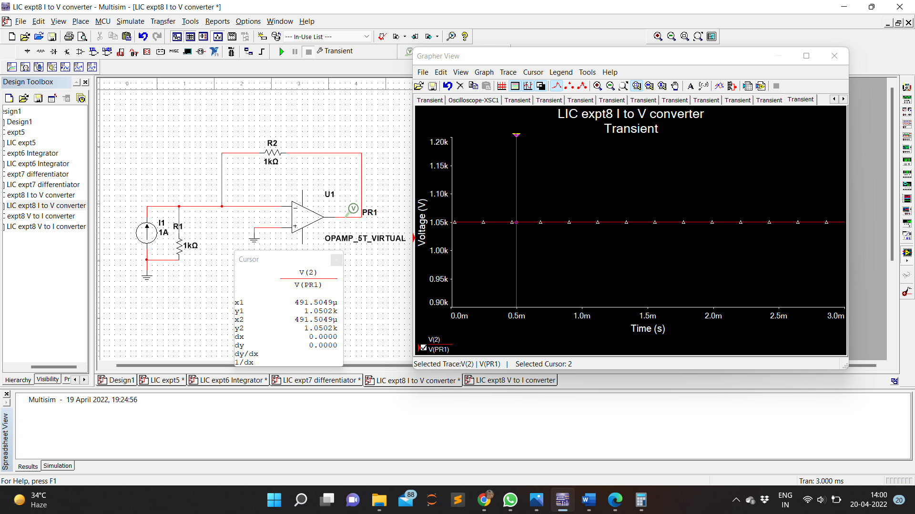

**CALCULATION:**

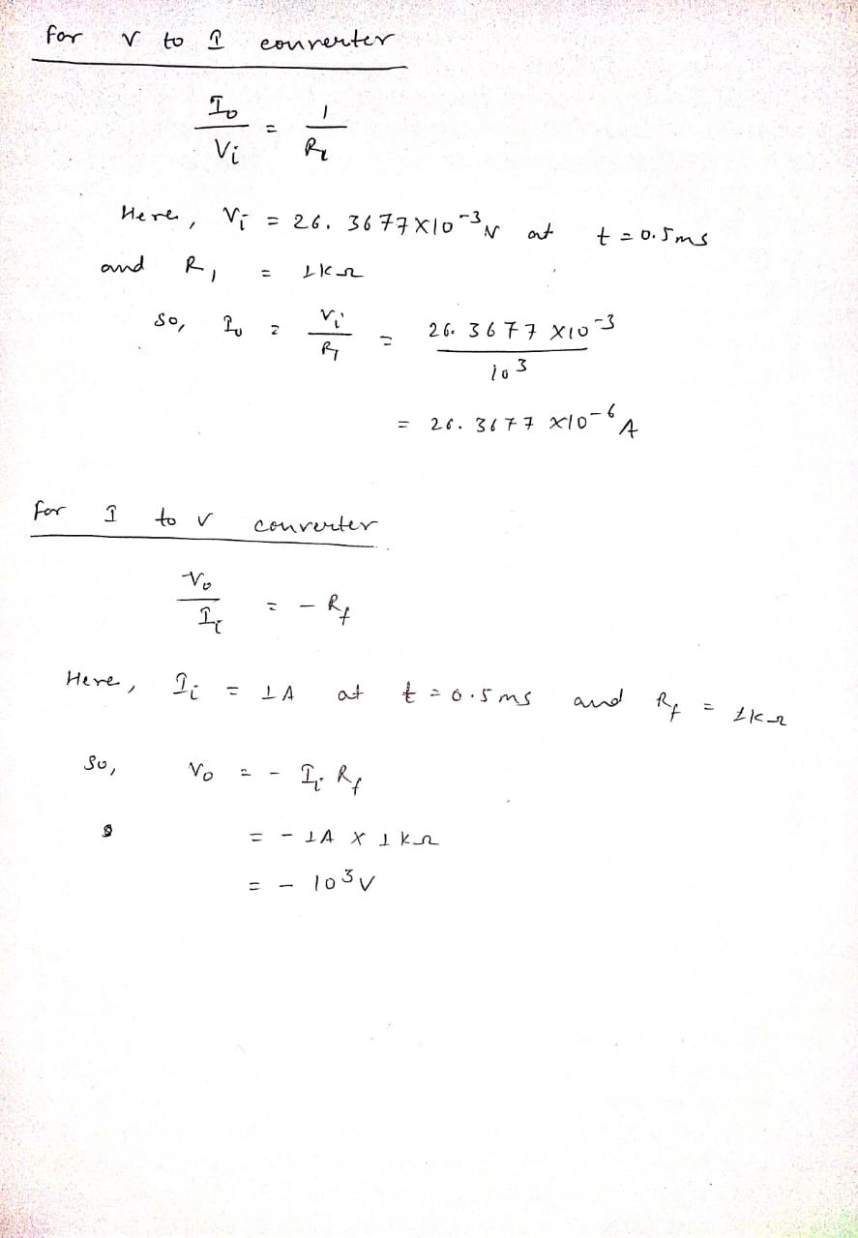

**RESULT:**

V to I converter and I to V converter is designed , simulated and verified using multisim.